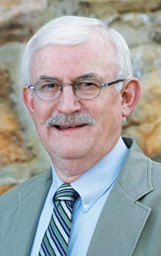
作者：Kenneth Stewart（肯尼斯·史都華）是喬治亞州萊克奧特芒廷（Lookout Mountain, Georgia）聖約學院（Covenant College）的神學終身教授。
譯：DeepL；
校：JFX。
2023-11-07

在過去的三個世紀裡，福音派基督徒已經習慣於認爲，屬靈影響力和復興的動力主要產生於英語地區。英語國家雖然中間隔著大洋，但卻共同在福音的復興上發揮著主導作用。
在 17 世紀 30 年代和 40 年代，穿梭在大西洋之上的不僅只有佈道家，還有各種通訊手段。19 世紀，查爾斯·芬尼（Charles Finney）將他首先在紐約州西部和俄亥俄州試用的奮興佈道方法帶到了英國城市。後來，D. L. 慕迪從其他佈道前輩們的經驗中汲取智慧，並奔波在大西洋兩岸。
1904 年的威爾士大復興（The Welsh Revival）在印度、朝鮮、斯堪的納維亞半島和加利福尼亞等地影響並推動了類似運動。20 世紀 30 年代的東非大復興是繼英國宣教士在那之前於當地傳福音之後的又一次運動，它加速了非洲及其他地區福音派基督徒的屬靈發展。
所有這些奮興都有一個共同點：英語是將關於這些運動（無論是源自馬薩諸塞州、威爾士還是烏干達）的報導傳遞給更遠地方基督徒的手段。但這些由來已久的認知正確嗎？像這樣的以英語作爲載體的傳遞網絡在大復興運動中是否像我們長期以來所認爲的那樣不可或缺？我們有充分的理由對此提出質疑。

其他的敘事
20 世紀 30 年代，埃德溫·奧爾（J. Edwin Orr，1912-1987）通過對全球旅行和編年史的挖掘，開始對上述命題進行反思。他撰寫了大量書籍，記錄了發生在五大洲的不同復興運動。2010年，科林·漢森（Collin Hansen）和約翰·伍德布里奇（John Woodbridge）在他們合著的《上帝的異象》（A God-Sized Vision: Revival Stories That Stretch and Stir）一書中敘述了國際上其他的復興運動。同年，馬克·肖（Mark Shaw）出版了《全球覺醒：20 世紀的復興如何引發基督教革命》（Global Awakening: How 20th-Century Revivals Triggered a Christian Revolution）一書。
一些著名的現代研究集中於歐洲文化，而我們會想當然地認爲這些文化中幾乎沒有覺醒和復興。雷金納德·沃德（Reginald Ward）寫於1992年的《新教福音派的覺醒》（The Protestant Evangelical Awakening）認爲，更爲著名的、發生在18 世紀英國和美國的大復興其根源在中歐，在受到天主教反宗教改革逼迫的新教徒中間。沃德是英國衛理公會的成員，他後來在2006年還寫下了《早期福音派運動：一部全球思想史》（Early Evangelicalism: A Global Intellectual History）一書。
2019 年，美國歷史學家安德魯·克洛斯（Andrew Kloes）的《德國的覺醒： 1815-1848 年啓蒙運動後的新教復興》（The German Awakening: Protestant Renewal After Enlightenment 1815–1848）開闢了新的視野：德國的福音派復興是一個巡迴佈道、由聖經協會分發聖經、成立向國內外宣教機構的時代，但英語世界對此知之甚少。
與這些著作相似類似，剛剛出版的《國際視野中的日內瓦大復興》（The Genevan 'Revéil' in International Perspective，2023 年出版，也有法文版）也是如此。很少有英語國家的福音派基督徒知道，1815 年拿破崙戰敗後不久，一場福音派的大覺醒就在日內瓦開始了，這場復興的影響範圍包括了瑞士和法國的法語新教，隨後蔓延到今天德國的萊茵地區、當時合併的比利時和荷蘭，以及後來成爲意大利的皮埃蒙特（Piedmont）地區。
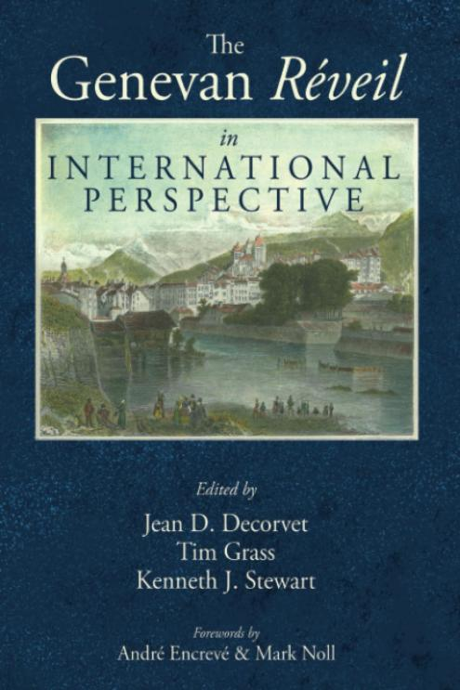

被忽視的復興
在這本醞釀十年之久的書中，來自七個國家的 20 位作者詳細講述了英語世界需要有更多了解的故事。
這場運動植根於摩拉維亞弟兄會的傳道人在瑞士和法國的巡迴事工，還有基督徒爲禱告和靈修團契而聚會的小組。來自海外的訪客也加入了這個佈道網絡：其中包括羅伯特·霍爾丹（Robert Haldane，蘇格蘭人）、亨利·德拉蒙德（Henry Drummond，英國人）和約翰·梅森·米切爾（John Mason Mitchell，美國人）。在此期間，許多日內瓦神學院學生的生活發生了改變。一些新的獨立教會開始建立。當時現有的改革宗教會中也有很大一部分得到了快速發展。
在這半個世紀的巡迴佈道、建立教會、分發資料和聖經的過程中，法語福音派誕生了。此時，在洛桑、日內瓦和巴黎成立了第一批法語新教海外宣教會。不久之後，魁北克、阿爾及利亞、馬達加斯加、中非和當時的印度支那等與歐洲法語國家有文化聯繫的地區都接收了來自歐洲的宣教士。新的神學院應運而生，爲這一福音運動提供牧師和宣教人才。阿道夫·莫諾（Adolphe Monod）、J.H. 梅爾·德奧比涅（J. H. Merle d'Aubigné）和路易·高森（Louis Gaussen）等著名宣教士和神學家站了出來，爲這場運動提供了指導。
英國和美國的福音派基督徒了解到這些發展（往往是從講法語的訪客那裡獲得第一手資料）後，紛紛支持這些福音事業。來自英國和美國的大量援助通過法國和瑞士的機構提供，這些機構僱用當地的其他機構傳福音、分發聖經，同時大量印刷書籍、聖經和小冊子。

復興的後果
這場復興在法國和瑞士引起了社區和社會的反響。學校開設了識字和算術課程。人道主義紅十字運動也在覺醒後應運而生。在這場運動開始後的 50 年內，法國和瑞士的福音派領袖在世界福音派聯盟（World Evangelical Alliance，成立於 1846 年）等國際論壇上佔據了重要位置。
從法國大革命和拿破崙帝國時代的混亂與無序中走出來，到 1850 年，歐洲法語區在福音的全球傳播中發揮了更大的作用。幾十年間，類似的故事也在德意志的土地上演著。
今天，我們看到同樣的原則在起作用，東南亞和拉丁美洲的福音運動已成爲全球教會基督教領導力和活力的重要源泉。英語世界並不總是全球基督教的中心，它也不一定是全球基督教大復興的源泉。
https://tc.tgcchinese.org/review/geneva-evangelical-awakening

The Geneva ‘Réveil’: An Almost Unknown Evangelical Awakening
SEPTEMBER 13, 2023 | KENNETH STEWART
For the past three centuries, evangelical Christians have grown accustomed to the idea that spiritual influence and momentum are generated in English-speaking regions. These regions, though separated by oceans, have exerted a common and dominant influence for good.
It was true in the 1730s and ’40s when not only evangelists but newsletters crisscrossed the Atlantic. In the 19th century, Charles Finney took his new methods, first tested in western New York and Ohio, to British cities. Later, D. L. Moody took pages from the playbooks of his predecessors when he crossed the Atlantic.
The Welsh Revival of 1904 set in motion similar movements as far afield as India, Korea, Scandinavia, and California. The East Africa Revival of the 1930s—a movement that followed the earlier implantation of the gospel by British missionaries—quickened the spirituality of evangelicals across Africa and beyond.
All these examples have one factor in common: the English language was the means by which reports of these movements (whether originating in Massachusetts, Wales, or Uganda) were relayed to Christians farther afield. But are these long-standing assumptions correct? Have English-language networks like these been as indispensable in movements of spiritual awakening as we’ve long supposed? There’s good reason to question this.

Different Narrative
A counternarrative began to be provided in the 1930s through the global travels and chronicling of J. Edwin Orr (1912–87), who wrote a myriad of books documenting movements of awakening on five continents. Much more recently, Collin Hansen and John Woodbridge described this international trajectory with their book A God-Sized Vision: Revival Stories That Stretch and Stir (2010) in the same year as Mark Shaw provided Global Awakening: How 20th-Century Revivals Triggered a Christian Revolution.
Some notable modern research has focused on European cultures in which we supposed little awakening and revival had occurred. Reginald Ward’s The Protestant Evangelical Awakening (1992) argued that the roots of the better-known movements in 18th-century Britain and America lay in central Europe, among Protestants harassed by the Catholic Counter-Reformation. Ward, a British Methodist, followed this up with Early Evangelicalism: A Global Intellectual History (2006).
In 2019, American historian Andrew Kloes opened up new vistas with The German Awakening: Protestant Renewal After Enlightenment 1815–1848. Here was an era of itinerant preaching, Scripture distribution by Bible societies, and the forming of home and foreign mission societies, about which the English-speaking world has had little awareness.

In a similar vein is the just-released The Genevan ‘Revéil’ in International Perspective (2023, also available in French). Few English-speaking evangelicals are aware that shortly after Napoleon’s defeat in 1815, there began at Geneva an evangelical awakening that leavened French-speaking Protestantism in Switzerland and France before spilling across borders into the Rhine region of today’s Germany, the then-combined Belgium and the Netherlands, and the Piedmont region of what would become Italy.

Overlooked Revival
In this volume (which was a decade in the making), 20 contributors, drawn from seven countries, detail a story the English-speaking world needs to know more about.
This movement was rooted in the witness of traveling Moravian evangelists in Switzerland and France; there were also cells of Christians meeting for prayer and devotional fellowship. Into this network of seekers entered foreign visitors: among them were Robert Haldane (Scottish), Henry Drummond (English), and John Mason Mitchell (American). During this time, the lives of many Genevan theological students were redirected. There were new independent congregations begun. And a good portion of the existing Reformed churches were quickened.
Francophone evangelicalism came to birth in this half-century of itinerant evangelism, church planting, and tract and Bible distribution. The first Francophone Protestant foreign mission societies were formed at this time in Lausanne, Geneva, and Paris. Before long, regions culturally linked to Francophone Europe such as Quebec, Algeria, Madagascar, central Africa, and the then-Indochina received missionaries. New theological colleges were established to provide this evangelical movement with pastors and evangelists. Preachers and theologians of stature, such as Adolphe Monod, J. H. Merle d’Aubigné, and Louis Gaussen emerged to guide the movement.

Evangelical Christians in Britain and America, learning of these developments (often firsthand from French-speaking visitors), threw their support behind these gospel enterprises. Extensive assistance from Britain and the U.S. was channeled through French and Swiss agencies that employed local agents to evangelize; engage in Scripture distribution; and print books, Bibles, and tracts.

Awakening’s Aftermath
Within France and Switzerland, there were communal and social repercussions that followed this awakening. Schools were opened to provide literacy and numeracy. The humanitarian Red Cross movement was birthed in its aftermath. Within 50 years of the dawn of this movement, French and Swiss evangelical leaders were taking prominent places in international forums such as the World Evangelical Alliance (founded in 1846).
Out of the chaos and disorder of the era of the French Revolution and Napoleonic Empire, Francophone Europe had by 1850 come to assume an expanded role in the worldwide advance of the gospel. A similar story was unfolding in those decades in German lands.
Today, we see the same principle at work as evangelical movements in Southeast Asia and Latin America have become significant sources of Christian leadership and vitality for the global church. The English-speaking world hasn’t always been the center of global Christianity, and it won’t necessarily be the source of its awakening.

https://www.thegospelcoalition.org/article/geneva-evangelical-awakening/

