腓利門書評論
http://www.cclw.net/Bible/flmspl.html

雅各書評論
http://www.cclw.net/Bible/ygspl/index.html

托馬斯L康斯塔布爾博士Thomas L. Constable is a former faculty member of DTS. Dr. Constable is the founder of Dallas Seminary’s Field Education department (1970) and the Center for Biblical Studies (1973), both of which he directed for many years before assuming other responsibilities. Today Dr. Constable maintains an active academic, pulpit supply, and conference-speaking ministry around the world. He has ministered in nearly three dozen countries and written commentaries on every book of the Bible. Dr. Constable also founded a church, pastored it for twelve years, and has served as one of its elders for over thirty years.
https://voice.dts.edu/contributor/thomas-l-constable/

Dr. Thomas L. Constable graduated from Moody Bible Institute in 1960 and later graduated from Dallas Theological Seminary.
Dr. Constable is the founder of Dallas Seminary's Field Education department (1970) and the Center for Biblical Studies (1973), both of which he directed for many years before assuming other responsibilities.
Today Dr. Constable maintains an active academic, pulpit supply, and conference-speaking ministry around the world. He has ministered in nearly three dozen countries and written commentaries on every book of the Bible.
Dr. Constable also founded Plano Bible Chapel, pastored it for twelve years, and has served as one of its elders for over thirty years.
https://www.studylight.org/commentaries/eng/dcc.html

Tom Constable
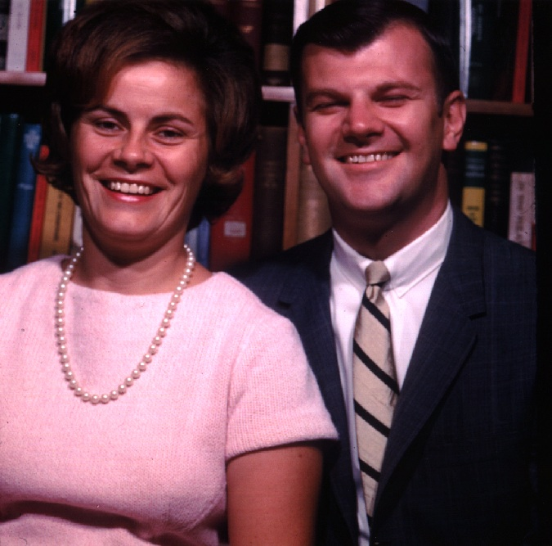
In 1966, Dr. Tom Constable began a life of ministry as a teacher/professor at Dallas Theological Seminary until his retirement May, 2011. In addition to teaching thousands of young men and women in the Bible Exposition Department for 45 years, Tom also founded and directed the Field Education Department (1970-85), founded and directed the Center for Biblical Studies (1973), directed the Doctor of Ministry degree program (1979-96) and during his last 15 years (1996-2011) served as the Department Chairman of Bible Exposition.

He has written commentaries on all 66 books of the Bible that continue to influence countless people all over the world through “Tom Constable’s Expository Notes on the Bible”. Dr. Constable’s notes are available here. Tyndale Seminary Press has published Thomas Constable’s Notes on the Bible in book form that may be purchased from various retailers.

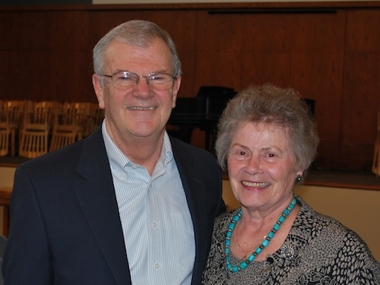

Through the years, Tom and Mary have also ministered in more than three dozen countries and have regularly hosted seminary students and families in their home. Their relational ministry has changed the lives of so many. Tom’s practical ministry of training pastors and missionaries to teach the Bible continues to multiply exponentially.

Tom and Mary’s influence is not just global – it’s personal. In 1968, the Constables founded Plano Bible Chapel and Tom served as pastor until 1980. He has continued to serve as an elder and elder advisory council member, teacher and pulpit speaker to this day. The Constables impact in each of our lives cannot be fully expressed or measured in earthly terms.

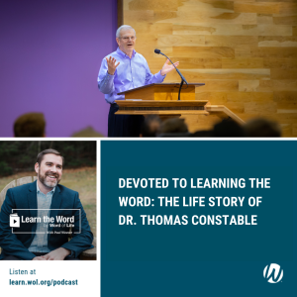
More than what he has done, Tom Constable is a model person of one who has committed his life to learning, living, and teaching God’s Word. Tom’s life story was recently recorded by Paul Weaver, Director of Word of Life Institute. Listen to the inspiring Word of Life Podcast.

https://planobiblechapel.org/tom-constable/
https://planobiblechapel.org/constable-notes/

