柯魯斯 (Colin G. Kruse)皆属安立甘背景，但立场皆不明。

Dr. Colin Kruse is a bible commentator and senior lecturer in New Testament at the Melbourne School of Theology.[1]
Kruse's academic education started at the Australian College of Theology and continued with study for his BDiv at the University of London. He remained at London to do his MPhil but moved to Fuller Theological Seminary to read for his Ph.D.[1]
After being ordained he initially worked in the Anglican ministry with parochial responsibility in Australia and the USA. He and his wife Rosemary joined the Church Missionary Society of Australia (CMS), where he served as a theological lecturer in Indonesia.[2] Follow this he pursued an academic career first at Ridley College (for 16 years) before moving to the then Bible College of Victoria, now the Melbourne School of Theology.[1]
He writes various journal articles on the New Testament, Old Testament, and the Dead Sea Scrolls, he has authored several books mainly of New Testment commentary and on various forms of Christian ministry.[1] Colin recently released a commentary on Paul's Letter to the Romans for the Pillar New Testament Commentary series by Eerdmans/IVP.
Besides journal articles on the New Testament, Old Testament and the Dead Sea Scrolls, Kruse has authored several books including Paul, the Law and Justification and New Testament Models for Ministry: Jesus and Paul. He has also written the Tyndale New Testament Commentary on 2 Corinthians and the Pillar New Testament Commentary titles The Letters of John and Paul's Letter to the Romans.[2]

https://en.wikipedia.org/wiki/Colin_G._Kruse

Dr Colin Kruse
Emeritus Scholar
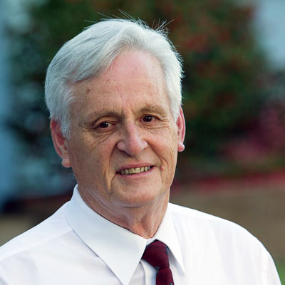
MEET COLIN

Colin teaches various New Testament subjects at undergraduate and postgraduate levels.
Colin and Rosemary came to Melbourne School of Theology (then called Bible College of Victoria) after sixteen years at Ridley College. In the years following his ordination into the Anglican ministry, Colin gained practical experience in parishes in Australia and the USA, also five years of missionary service with the Church Missionary Society of Australia (CMS) as a theological lecturer in Indonesia, before taking up his positions at Ridley College and the Melbourne School of theology.
Colin is a prolific writer. Besides journal articles on the New Testament, Old Testament, and the Dead Sea Scrolls, he has authored several books including New Testament Models for Ministry: Jesus and Paul (Marshall, Morgan and Scott); The Second Epistle of Paul to the Corinthians (IVP/Eerdmans); Paul, the Law and Justification (IVP/Hendrickson), and commentaries on The Letters of John (IVP/Eerdmans) and The Gospel according to John (IVP/Eerdmans).
Colin recently released a commentary on Romans for the Pillar New Testament Commentary series (Eerdmans/IVP).

DEGREES
ThL (Australian College of Theology)
BDiv (University of London)
MPhil (University of London)
PhD (Fuller Theological Seminary)

https://www.mst.edu.au/faculty/colin-kruse/

