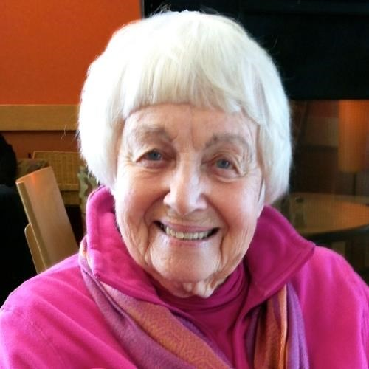

THEA VAN HALSEMA OBITUARY
Van Halsema, Thea B. Grand Rapids, MI Born Thea Jane Bouma to Clarence and Tessie Luidens Bouma in 1924, Thea B. Van Halsema died on November 8, 2016. She graduated from Oakdale Christian School, Grand Rapids Christian High School and Calvin College, and attended Case Western Reserve University for postgraduate studies in social work. She married Dick Van Halsema in 1948. Thea was an accomplished teacher, author, counselor, vocalist and mother of five. She was a woman of faith, and found her greatest joy in recent years spending time with her family and friends in Grand Rapids, as well as keeping in touch with others in many countries. She was known as the capable and loving "Mrs. Van" partner of "Dr. Van" as they served and traveled together in many Christian endeavors around the world during their 56 years of marriage. Her career also included serving as social work professor and Dean of Women at Reformed Bible College (now Kuyper College); working with The United Way of Grand Rapids; authoring books about Christian historical figures such as John Calvin and the history of the Christian Reformed Church and its creeds, many of which have been translated and are still in use in other languages; participating in early Christian Reformed Church committees about the role of women in the denomination; and serving on the board of the Latin America Mission. She was preceded in death by her husband Dr. Dick Van Halsema, sister June Bouma Bangma, son David Van Halsema and granddaughter Dana Van Halsema. Her surviving children are Nancy Tess Van Halsema Lindholm, Clark Van Halsema, Emily Amahl Van Halsema and Dick van Halsema, Jr. Surviving grandchildren are Thea Van Halsema Brophy; Ian and Toby Van Halsema; Luke and Anna Lindholm; and Leah, Emma, Elizabeth and Holly van Halsema. Surviving great-grandchildren are Max Loughin, Vivian Van Halsema, Rhys Brophy and Harrison Brophy. Visitations will be held from 2 p.m. to 4 p.m., and from 6 p.m. to 8 p.m., on Thursday, November 17 at Calvin Christian Reformed Church, 700 Ethel Ave SE, Grand Rapids, MI. A service of celebration and thanksgiving, followed by a reception, will be held at the same location on Friday, November 18, at 2 p.m. Memorial contributions may be made to the Calvin Christian Reformed Church Family Assistance at the church address.

https://obits.mlive.com/us/obituaries/grandrapids/name/thea-van-halsema-obituary?id=16154394

