改革的玫瑰经祷文（A Reformed Rosary Prayer）
Posted on 1st 8月 2021
注：此非公祷之文（Common prayer），而仅属私下敬虔（Private devotion）之用。
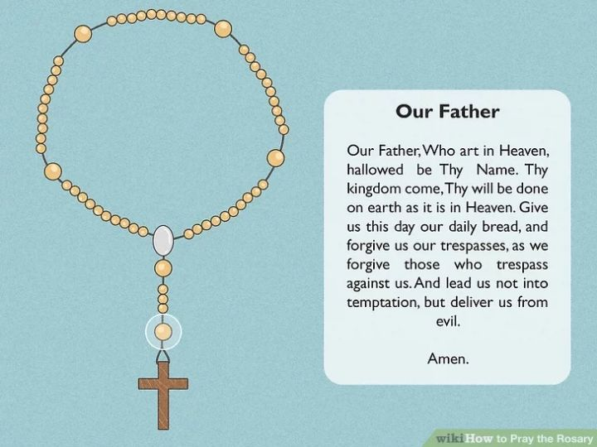

始礼文 (Opening prayers)：
¶从十字架开始，诵圣三一之号：
奉圣父、圣子、圣灵之名。阿们。
In the name of the Father, and of the the Son, and of the holy Ghost. Amen.
¶至第一个大念珠时，诵主祷文（含荣耀祷词）：
我们在天上的父：愿人都尊你的名为圣。愿你的国降临；愿你的旨意行在地上，如同行在天上。我们日用的饮食，今日赐给我们。免我们的债，如同我们免了人的债。不叫我们遇见试探；救我们脱离凶恶。因为国度、权柄、荣耀，全是你的，直到永远。阿们。
Our Father, which art in heaven, hallowed be thy Name. Thy Kingdom come. Thy will be done on earth, as it is in heaven. Give us this day our daily bread. And forgive us our trespasses, as we forgive them that trespass against us. And lead us not into temptation, but deliver us from evil. For thine is the kingdom, and the power, and the glory, for ever and ever. Amen.
¶三个小念珠，照顺序诵这三对启应，该文取自公祷书日课早晚祷的始礼文：
启：求主使我开口。
应：我的口里就称颂主。
℣: O Lord, open thou my lips.
℟: And my mouth shall show forth thy praise.
启：求上帝速速拯救我。
应：恳求主快快帮助我。
℣: O God, make speed to save me.
℟: O Lord, make haste to help me.
启：我的灵要赞美主。
应：愿主的名受赞美。
℣: Praise the Lord, O my soul.
℟: The Lord’s Name be praised.
¶三个小念珠其后的大念珠处读荣耀颂：
但愿荣耀归于圣父、圣子和圣灵；起初这样，现在这样，以后也这样：永无穷尽。阿们。
Glory be to the Father, and to the Son: and to the Holy Ghost; As it was in the beginning, is now, and ever shall be: world without end. Amen.

每一端 (Decade)：
玫瑰念珠的主体部分被分为五节，以一大念珠或特殊材料制成的念珠相分隔，每一节内有十个小念珠，称之为一端（Decade即拉丁文十之意），一套念珠共有五端。
传统上，这五端会根据不同日子，要通过童贞马利亚的视角冥想和思考、纪念圣子耶稣的五件奥妙事迹，同时诵念祷文。除了所谓“光明五端”中的圣母肉身升天内容，为罗马一派之观点，其余皆为福音书所记载，并无迷信或谬误，而此两端亦可改易为更广泛的纪念圣徒相通、和思考人子显现之日和新耶路撒冷之事。
¶默想的奥迹内容如下：
喜乐五端：即把祈祷意向集中于默想基督的诞生。周一、周六。
1.圣马利亚领报、2.圣母访亲、3.耶稣基督诞生、4.献主于圣殿、5.耶稣十二岁圣殿讲道。
光明五端：周四。
1.耶稣受洗、2.耶稣参加迦拿婚礼、3.登山宣讲天国之道、4.他泊山显圣容、4.设立圣餐。
痛苦五端: 周二、周五。
1.客西马尼园祈祷、2.耶稣受鞭打、3.受荆棘冕冠、4.背十架上山、5.十架受难而死。
荣耀五端：周三。
1.耶稣复活、2.耶稣升天、3.圣灵降临、4.诸使徒事迹及圣徒相通、5.新耶路撒冷。
主日：将临期用喜乐五端、大斋期用痛苦五端、复活节期和常年期用荣耀五端。
每一端内祷词：
¶每一端前的大念珠（第一端前为念珠交结处，有时为一圆牌），当诵主祷文：
我们在天上的父：愿人都尊你的名为圣。愿你的国降临；愿你的旨意行在地上，如同行在天上。我们日用的饮食，今日赐给我们。免我们的债，如同我们免了人的债。不叫我们遇见试探；救我们脱离凶恶。阿们。
Our Father, which art in heaven, hallowed be thy Name. Thy Kingdom come. Thy will be done on earth, as it is in heaven. Give us this day our daily bread. And forgive us our trespasses, as we forgive them that trespass against us. And lead us not into temptation, but deliver us from evil. Amen.
¶在冥想前文所叙奥迹的时候，在每一端内的十个小念珠处，诵下文，共十次：
此文即古祷文“Ave Maria"，路加福音第一章之内容，也即所谓“圣母经”。但古祷文未有后世添加之“天主圣母玛利亚…为我们罪人祈求天主”等句。马丁·路德和慈运理之苏黎世改革教会均曾继续使用此古旧版本。
万福马利亚，你满受恩典，主与你同在。你在妇女中为有福，你所怀的胎，耶稣，同为有福。
Hail Mary, full of grace, the Lord is with thee. Blessed art thou amongst women, and blessed is the fruit of thy womb, Jesus.
¶可再跟读此祷文：
马利亚之子，永生上帝的儿子，现在和我们临终之时，求主怜悯我们。阿们。
Son of Mary, son of the living God, have mercy upon us, now, and at the hour of our death. Amen.
¶若不用以上两文，也可用耶稣祷文（Jesus Prayer）。稍根据公祷书总祷文改写：
主耶稣基督，上帝之子，怜悯我们悲惨罪人。
Lord Jesus Christ, Son of God, have mercy upon us miserable sinners.
¶至十个小念珠诵毕，则诵读荣耀颂一遍：
但愿荣耀归于圣父、圣子和圣灵；起初这样，现在这样，以后也这样：永无穷尽。阿们。
Glory be to the Father, and to the Son: and to the Holy Ghost; As it was in the beginning, is now, and ever shall be: world without end. Amen.

结礼文 (The conclusion)：
¶五端祈祷完毕，诵《尊主颂》，也称马利亚之歌:
我心尊主为大；我灵以上帝我的救主为乐；
My soul doth magnify the Lord: and my spirit hath rejoiced in God my Saviour.
因为他顾念他使女的卑微；从今以后，万代要称我有福。
For he hath regarded: the lowliness of his handmaiden. For behold, from henceforth: all generations shall call me blessed.
因为那有权能的为我做了大事；他的名是圣的。
For he that is mighty hath magnified me: and holy is his Name.
他怜悯敬畏他的人，直到世世代代。
And his mercy is on them that fear him: throughout all generations.
他用膀臂施展大能；他赶散心里妄想的狂傲人。
He hath showed strength with his arm: he hath scattered the proud in the imagination of their hearts.
他叫有权柄的失位，叫卑贱的升高。
He hath put down the mighty from their seat: and hath exalted the humble and meek.
他叫饥饿的饱餐美食，叫富足的空手回去。
He hath filled the hungry with good things: and the rich he hath sent empty away.
他扶助了他的仆人以色列，不忘记施怜悯，
He remembering his mercy hath holpen his servant Israel:
正如他对我们的列祖说过，怜悯亚伯拉罕和他的后裔，直到永远。
as he promised to our forefathers, Abraham and his seed, for ever.
但愿荣耀归于圣父、圣子和圣灵；
Glory be to the Father, and to the Son: and to the Holy Ghost;
起初这样，现在这样，以后也这样：永无穷尽。阿们。
As it was in the beginning, is now, and ever shall be: world without end. Amen.
¶然后可诵《使徒信经》：
我信上帝，即全能之圣父，创造天地之主。
I believe in God the Father Almighty, Maker of heaven and earth:
我信其独生之圣子，我主耶稣基督；
And in Jesus Christ his only Son our Lord,
我信耶稣为受圣灵感动之童贞女马利亚所生；
Who was conceived by the Holy Ghost, born of the Virgin Mary,
我信耶稣在本丢彼拉多手下遇难，被钉十字架，死而埋葬；
Suffered under Pontius Pilate, was crucified, dead, and buried:
我信其降至阴间，第三日从死复活；
He descended into hell; The third day he rose again from the dead;
我信其升天，坐于全能之天主父之右；
He ascended into heaven, and sitteth on the right hand of God the Father Almighty;
我信其日后必自彼处降临，审判生人死人。
From thence he shall come to judge the quick and the dead.
我信圣灵；我信圣而公之教会，我信诸圣相通功；
I believe in the Holy Ghost; The holy Catholick Church; The Communion of Saints;
我信赦罪之恩；我信身死后必复活；我信永生。
The Forgiveness of sins; The Resurrection of the body, And the Life everlasting.
阿们。
Amen.
¶最后以使徒祝文作结：
愿主耶稣基督的恩惠，上帝的慈爱，圣灵的感动，常与我们同在。阿们。
The grace of our Lord Jesus Christ, and the love of God, and the fellowship of the Holy Ghost, be with us all evermore. Amen.

