https://en.wikipedia.org/wiki/Jay_E._Adams

Dr. Jay E. Adams was founder of the Christian Counseling and Educational Foundation in Philadelphia,Pa., the National Association of Nouthetic Counselors, and the Institute for Nouthetic Studies. He trained and taught counselors at the Redeemer Biblical Counseling Training Institute in Moore, S.C. He authored numerous books on counseling, preaching, theology, and pastoral ministry including, Competent to Counsel, The Christian Counselor's Manual, Theology of Counseling, Christian Living in the Home, How to Help People Change.
https://www.ligonier.org/learn/teachers/dr-jay-adams

Jay E. Adams (1929–2020), a pioneer in biblical counseling, served as a pastor, church planter, denominational executive, seminary professor, author, and lecturer. He taught homiletics at Westminster Theological Seminary in Philadelphia and was the director of advanced studies at Westminster Seminary in California. He was the founder of the Christian Counseling & Educational Foundation (CCEF), the Association of Certified Biblical Counselors (formerly NANC), and the Institute for Nouthetic Studies (INS). Adams was the author of over one hundred books, including the best-selling Competent to Counsel, a book that launched the modern biblical counseling movement. He was a recipient of The Order of the Palmetto, the highest civilian honor awarded by the State of South Carolina.
https://www.prpbooks.com/authors/jay-e-adams

Jay E. Adams (January 30, 1929–) is a Reformed Christian author who received his doctorate in preaching but is mostly known for his book, Competent to Counsel, in which he states that any Christian is more competent to counsel than any secular psychologist. He recently wrote Sermon Analysis — A Preacher's Personal Improvement Textbook and Workbook. He has published more than 100 books, which have been translated into 16 languages.
https://www.sermonaudio.com/search.asp?speakeronly=true&currsection=sermonsspeaker&keyword=Dr._Jay_E._Adams

Jay E. Adams
Posted on December 11, 2018by Greg E. Gifford
By Ethan Berthiaume
I. Known For
Jay E. Adams is a reformed American Christian author who is best known for influential writings that helped found modern Biblical Counseling. He has written over 100 books, the most famous of which being Competent to Counsel. Jay Adams introduced the method of “nouthetic” counseling, which centers around conforming to scriptural principles for the purpose of spiritual growth. This method eventually became a movement which we know today as Biblical Counseling. Adams has been called a “father of Biblical Counseling” for his foundational influence on the methods and movements that shaped it (Powlison, 44).

II. Biography
Jay Adams was born to Joseph Edward and Anita Louise Adams in Baltimore, Maryland on January 30, 1929. He was married to Betty Jane Whitlock on June 23, 1952. They had four children: Holly, Todd, Clay, and Heather (“Jay E. Adams – Exodus Books”).
Jay became came to know Christ at the age of 15 after being gifted a copy of the New Testament by a friend. Adams became fascinated with God’s word, and he majored in Greek solely for the purpose of having an understanding what God’s word teaches (Adams, Ligonier Ministries).
Adams went on to study and receive formal theological and seminary training at several different schools. These include the Reformed Episcopal Seminary, John Hopkins University, Pittsburgh-Xenia Seminary, Temple University School of Theology, and the University of Missouri. He then went on to pastor at several churches alongside the East Coast in Pennsylvania and New Jersey. Adams began working as a professor at Westminster Theological Seminary in Philadelphia, and eventually became the director of the Doctoral program at Westminster Theological Seminary in California. Following this, he went on to plant churches in South Carolina, where he pastored until 1999 (“Jay E Adams, Ph. D.”).
Jay Adams first became interested in counseling early in his pastoral ministry after experiencing a difficult situation with the death of a man he failed to comfort in a difficult circumstance. After this, Adams asked the Lord to help him become effective in counseling ministry. While studying at the Temple University School of Theology, Adams took a course on psychological counseling. Here, he was discouraged by how foundationally speculative the methods were. Adams became more interested in the Biblical view of psychology while studying under Psychologist, O. Hobart Mowrer (1907-1982). Mowrer taught counseling techniques that integrated sin as an influence on mental health. While Adams did not entirely agree with all of Mowrer’s views, he became more fascinated with applying the Bible to the techniques of soul care. Adams continued to study and develop a model founded on Biblical principles known as “nouthetic counseling”. In 1970, he published his most famous work, Competent to Counsel, which argued that that all Christians can become fully equipped for the work and ministry of soul care if their methods were centered around biblical principles and views of man (Powlison, 35-45).
The publication of this book caused much controversy in the Christian community, as more and more pastors began to adopt Adam’s method of “nouthetic counseling” into their ministry. This movement eventually grew into what we now know today as Biblical Counseling (Powlison, 44).
Adams was honored at the first International Congress on Christian Counseling in 1988 in Atlanta as one of the three fathers of Christian Counseling, for his essential influence on the movement (Powlison, 43).
Jay Adams Retired in 1999 from pastoral ministry but has continued to write and lecture on Biblical Counseling. He founded the Institute for Nouthetic Studies (INS) in the year 2001. At the time of this publication, he currently resides in South Carolina and is still involved in teaching at INS (“Jay E Adams, Ph. D.”)
Jay Adams was revolutionary for his time, as psychology had taken a preeminent role in the art of soul care. Adams challenged the skeptical theories of psychology and developed a model that helped push the church towards scripture-based methods of helping people.

III. Important Theological Views
Nouthetic Counseling
Jay Adam’s most prominent, and certainly most well-known accomplishment is his method of nouthetic counseling. The word nouthetic comes from the Greek word noutheteō
An important distinction of Jay Adams models is their rejection of psychological theories and models that contradict the Bible. This mainly has to do with the issue of sin as it relates to a believer’s behavior, a factor that is most often excluded from modern psychological models. Adams’ method of nouthetic counseling is distinct in that it holds to the Bible as the sufficient and authoritative tool for equipping believers for all things needed for life and godliness (2 Timothy 3:16-17).

IV. Works/Publications
Jay Adams has written over 100 books that relate to pastoral ministry and counseling. These have been translated into 16 different languages. The most famous and influential of published works are: Competent to Counsel (1970), The Christian Counselors Manuel (1973), A Theology of Christian Counseling (1979), Shepherding God’s Flock: A Handbook on Pastoral Ministry, Counseling, and Leadership (1974) (“Adams, Jay E. 1929- [Worldcat Identities]”.)

Bibliography
“Jay E. Adams – Exodus Books”. Exodusbooks.Com,
https://www.exodusbooks.com/jay-e-adams/2716/.
Accessed 30 Nov 2018.

Adams, Jay. “Competent To Counsel: An Interview With Jay Adams By Jay Adams”. Ligonier Ministries. 2014. Accessed 30 November 2018

“Jay E Adams, Ph. D.”. Nouthetic.Org, http://www.nouthetic.org/about-ins/our-faculty/8-about-ins/6-jay-adams-biography.
Accessed 29 Nov 2018.

“Adams, Jay E. 1929- [Worldcat Identities]”. Orlabs.Oclc.Org,
http://orlabs.oclc.org/identities/lccn-n50-36855/.
Accessed 30 Nov 2018.

Collins, Gary R; Johnson, Eric L; Jones, Stanton L (2000). Psychology & Christianity. Downers

Grove, IL, USA: InterVarsity Press. pp. 36–37. ISBN 0-8308-2263-1.

Powlison, David. The Biblical Counseling Movement. New Growth Press, 2010, pp. p. 35-44.

Ligonier Ministries, 2014, https://www.ligonier.org/learn/articles/competent-counsel-interview-jay-adams/.
Accessed 1 Dec 2018.

https://encyclopediabc.com/2018/12/11/jay-e-adams/

Dr. Jay E. Adams entered into his eternal rest with his Lord on November 14, 2020. He was 91 years old.
Jay Adams was best known as the founder of the modern Biblical counseling movement, launched with the publication of his groundbreaking book Competent to Counsel in 1970. He was a champion for the cause of biblical sufficiency and against the encroachment of secular psychology into the counseling rooms of pastors and Christian laypersons.

Early life and conversion.
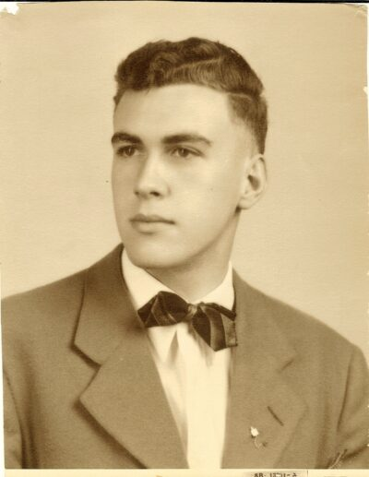
Jay Edward Adams was born on January 30, 1929, in Baltimore, Maryland. His father was a beat cop and his mother a secretary. Neither of his parents attended church, and he received no instruction in spiritual matters as a child.
Adams was a precociously bright youngster and skipped a year of high school to graduate when he was just 15 years old. His first consideration of any spiritual matter occurred when a neighborhood friend complained to him about a book he had been reading by a man who denied the Scriptures. Adams wondered why his friend, a believer, was so exercised about the Bible and decided to investigate. He found the Gideon New Testament his father had been given as a soldier in the Great War and began to read. By the time he finished reading the Gospel of John, God opened his heart and he came to believe what he was reading was true.
His friend invited him to his church where he heard the Scriptures preached by a pastor who was a skilled expositor, and he began to grow. Following graduating from high school, he asked his pastor where he could go to learn the Bible better. His pastor pointed him to the Reformed Episcopal Seminary in Philadelphia, where an exception had to be made so Adams could enroll as a 15-year-old student with no undergraduate degree.
The next three years were rigorous for Adams, who had no previous familiarity with the Scriptures. He learned quickly and soon developed a love for the study of the Scriptures in the original languages. Upon completion of his graduate coursework, he enrolled at Johns Hopkins University and majored in classic languages. Upon graduation in 1952, he was awarded both his undergraduate and graduate degrees on the same day.
During his Seminary and College days, Adams did street preaching and preached at country churches and rescue missions. He served as director of the local Youth for Christ chapter and sang in a men’s quartet. But most importantly, he met and eventually married Betty Jane Whitlock on June 23, 1951.

Early Ministries.
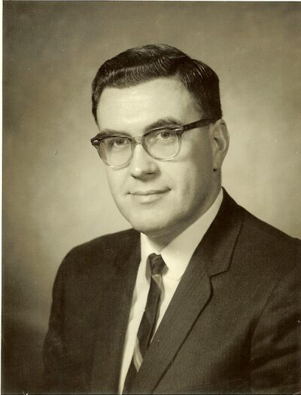
In 1952 Adams became the pastor of a United Presbyterian church in Eighty-Four, Pennsylvania, and soon became embroiled in denominational conflict. He opposed a proposed merger with a liberal denomination and was chosen to debate the merger’s leading proponent. The debate did not end well for his opponent, who tried to deny the existence of liberalism in his denomination. Adams had done his homework and caught his opponent in a number of lies by quoting back to him his earlier writings.
Adams pastored several other small churches while taking further studies at Temple University, where he studied homiletics under Andrew Blackwood, who impressed Adams deeply and instilled in him a love for preaching.
In 1958 Adams moved to Kirkwood, MO and became the director of Home Missions for the Bible Presbyterian denomination. While traveling, he often had discussions with pastors who asked about his understanding of eschatology. Because he was asked so frequently, he decided to put his view into a small book, which he entitled Realized Millennialism (a term he preferred over “amillennialism”). Most pastors in the denomination were premillennial, however, and his book generated a degree of controversy. Not desiring to be a cause of division, he resigned to focus on his Ph.D. studies at the University of Missouri.
By this time in his academic career, Adams had a mature grasp on his theology and was an accomplished Greek scholar. But his burden for the state of preaching he observed in churches grew, leading him to focus his Ph.D. work on learning to communicate effectively. For three years while he did his Ph.D. work, he preached on weekends, bagged groceries at a local market, read law books onto tape for blind students, and taught classes at the university as an intern.

Learning to Counsel.
In 1963 he moved to New Jersey, became the pastor of an Orthodox Presbyterian Church, and was invited to teach homiletics part-time at Westminster Theological Seminary. As the newest instructor, he was assigned a course that none of the other teachers wanted to teach, a course entitled “Poimenics” (more commonly known as pastoral theology). As a part of that course, he was expected to teach something about pastoral counseling.
Adams had no experience teaching counseling and limited counseling experience as a pastor, so he simply taught the notes the previous teacher had given him. He found no theological substance in what he had been handed and determined to study and do better before he would have to teach the course again the next year. As he studied, however, he found nothing to help him. He pored over everything he could find written from a Christian perspective and found only Freudian and Rogerian dogma. He studied secular texts and sought to find useful material for the Christian counselor. “I began to conclude that I was too obtuse to understand what I was reading in those books,” he recalled later. “All the other seminaries were able to integrate these secular, pagan concepts in their curriculum, but I could not see how to do it.”
In 1965, Adams was offered the opportunity to accompany O. Hobart Mowrer for six weeks. Mowrer was a past president of the American Psychological Association and had written a book Adams had found to be provocative. In it, Mowrer, an atheist, asked the question, “Has evangelical Christianity sold its birthright for a mess of psychological pottage?”
Adams watched Mowrer confront his counselees about their actions, urge them to take responsibility, and not hide behind psychological labels. This was an unusual tack for a secular psychologist to take, but Adams watched Mowrer find far more success with it than his contemporaries. Mowrer was an iconoclast who challenged the common conclusions of those in his discipline. While Adams was grateful for the opportunity to observe Mowrer that summer, he stood far off from Mowrer’s behaviorism. “Mowrer was skilled at throwing stones through the psychologists’ windows,” Adams would later say, “but he had nothing to replace the broken glass to keep the bugs out.”
That summer with Mowrer was eye-opening for Adams. The reason he could not make secular psychological concepts integrate with the Scriptures was because they did not integrate! As a result of this epiphany, Adams was able to set aside the current psychological dogmas and focus on what the Scriptures had to say about people and their problems. Mowrer provided the bulldozer Adams needed to clear the site upon which he could build a counseling system from the building materials of the Scriptures. Adams began to schedule more and more counseling and used each session as an impetus to search the Scriptures for specific solutions to the problems that were presented. He invited students to sit in on counseling sessions and then debated with them how best to proceed after each session and how the Scriptures met the need. In 1968 he formed the Christian Counseling and Educational Foundation (CCEF) to serve as a kind of laboratory for his studies.
As he studied counseling issues, Adams began to form a counseling system. He knew every system of thought—theological, philosophical, mathematical—eventually got tagged with a label. He was loath to think that anyone would ascribe his name to his system in some way, so he decided to use an anglicized form of the Greek word Paul used for counseling and coined the word “nouthetic.” That system began to crystalize into a set of notes Adams wrote for his seminary class, which made their way into the hands of a publisher who asked Adams to work them into a book.
Before publication, however, the publisher arranged for Adams to forward his manuscript to a half dozen men who were teaching counseling in other seminaries and invite their critique. These men met with Adams at an airport hotel and reported their conclusions. Most were in agreement with Adams’ basic thesis, that secular psychological concepts had invaded the church, and that something should be done about it. Adams’ book, however, was not that something. It was too sharp, too accusing. The tone was all wrong and should be more irenic.
Adams weighed the criticisms carefully but asked himself, if these men agreed he was fundamentally correct, and that changes needed to be made, what were they doing to effect change? They all had platforms from which they could advocate change. What were they accomplishing? As a result, Adams concluded his manuscript was not sharp enough, and he worked to toughen it up even more.

Competent to Counsel.
When Competent to Counsel was published in 1970, it turned the Christian counseling world upside down. In it, Adams demonstrated how the three primary secular psychological systems—those of Freud, Rogers, and Watson/Skinner—stood in opposition to the Scriptures and must be rejected by Christian counselors.[He used the term “Christian” counseling rather than “Biblical” counseling as it did not occur to him then that anyone would think Christian counseling could be anything other than biblical.] He unpacked the Greek word nouthesia and demonstrated how the Apostle Paul engaged in the kind of counseling he was advocating, taking the title of his book from Paul’s statement in Romans 15:14,

「
I am convinced about you, my brothers, that you yourselves are full of goodness, filled with all knowledge, and competent to counsel one another.
」

The years that followed the publication of Competent to Counsel were a whirlwind of activity for Adams. Conservative pastors received his book enthusiastically, but those who were invested in the secular psychological systems Adams condemned savaged it. Invitations to lecture and explain his approach poured in, and because Adams was well trained as a public speaker, audiences found him to be a powerful advocate for the use of the Scriptures in counseling. Adams was glad to defend his views, but he quickly realized that while it was necessary to be polemic in Competent to Counsel, it would be necessary to provide solid, practical help with the many counseling issues that confronted pastors. To meet this need, he published The Christian Counselor’s Manual in 1973.

The Millhouse.
By 1976 Adams had traveled the world, explaining his views and exhorting pastors to minister the Word fearlessly in the counseling room. He continued to teach at the Seminary, he and his followers had formed the National Association of Nouthetic Counselors, and he had published fifteen other books. But it was a schedule that was taking a toll on his body. He developed heart problems brought on by exhaustion, and his doctors and family urged him to slow down. So he resigned from the Seminary, turned the administration of CCEF over to a co-worker, and moved his family to rural Georgia. He bought an old grist mill and went to work remodeling it into a home.
Adams continued to travel and teach, but at a much slower pace. For the next six years, he was able to devote much more time to writing. From the peace and seclusion of the Millhouse, Adams produced some of his most important works, including his translation of the Greek New Testament, which he published with extensive counseling helps as the Christian Counselor’s New Testament.

Back to the Classroom.
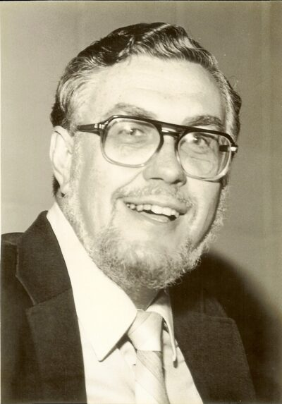
In 1982 Adams accepted an invitation to establish a D.Min. program in Homiletics at Westminster Theological Seminary in California. Because he could teach his classes in week-long modules, he would have the freedom to travel and continue to write. Adams generally disliked the strictures of academia, but he found the freedom that Westminster offered to be compelling. As a final project, students were expected to write something busy pastors would find to be practical, and they were required to get their project published. As a result, many helpful books were published by Adams’ students, several of which are still assigned reading in other homiletics programs.

Church Planter.
Adams gave Westminster a five-year commitment. He believed he could have the program established and would be able to turn it over to another. He stayed longer, but in 1990 he moved to the upstate of South Carolina, where a friend in the ARP denomination invited him to plant a church in a growing suburb of Greenville where the ARP church had secured a prime piece of property. His son-in-law, a recent seminary graduate, joined him, and together they planted the Harrison Bridge Road Presbyterian Church in Simpsonville. The Adams purchased a small rural acreage near Enoree, SC where they continued to live until his death.
Adams enjoyed the return to pastoral ministry, preaching every week, and doing regular counseling once again. Also, in partnership with a friend, he established Timeless Texts, a small publishing company whose primary purpose was to publish his books.

Retirement.
Adams retired from his church in 1997, at which time the Governor awarded him the Order of the Palmetto, the highest civilian honor awarded by the state of South Carolina. Retirement afforded him the opportunity to devote more time to writing, and Timeless Texts allowed him to get things into print much quicker. His Christian Counselor’s Commentary was a product of these years.
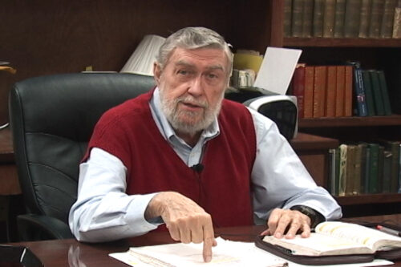
Retirement also afforded him time to teach. Adams’ son-in-law, who was now pastoring the Redeemer ARP church in Moore, SC, invited him to establish a counseling training center in his church. Requests quickly came for video and audio of Adams’ lectures. Rather than send out recordings in a haphazard way to all who asked, he decided to form the Institute for Nouthetic Studies (INS) and build a structured curriculum that would include all he considered essential in a training program. By then, new technology allowed him to make the lectures more readily available to students.
As the years took a toll on his body, Adams began to consider the future of his retirement ministries. Donn Arms, the director of INS, had developed a relationship with Mid-America Baptist Theological Seminary in Memphis and they approached Adams with the prospect of merging the Institute with the Seminary. This was accomplished in 2015. After Adams’ partner at Timeless Texts died, he assigned the copyrights to his books to INS, which began the process of bringing all of Adams’ books back into print.

Jay Adams, the Author.
A wag once introduced Adams as “a man who has never had an unpublished thought.” With over 100 books to his credit, few authors have been as productive as Jay Adams over a lifetime. While many books dealt with counseling issues, other books covered a surprising spectrum of issues including theology, hermeneutics, Christian living, a devotional book, preaching (including a book for laymen on how to listen to a sermon), pastoral ministry, fiction, aging, guidance, eschatology, church conflict, and commentaries.
Adams labored to be clear when he wrote, a style that led critics to accuse him of being simplistic. For Jay, complexity was often the cover for error while clarity was the cousin of truth. Through its Institute for Nouthetic Studies, Mid-America Baptist Theological Seminary is working to bring all of Adams’ books back into print so generations to come will be able to study and learn from Jay Adams.
Jay Adams touched the lives of millions of believers around the world through the students he taught, the books he wrote, the counselee’s helped by nouthetic counselors, and his lectures, podcasts, and videos. By God’s good provision, His church will be able to learn and profit from the ministry of Jay Adams for generations to come.

https://nouthetic.org/about/jay-adams/

