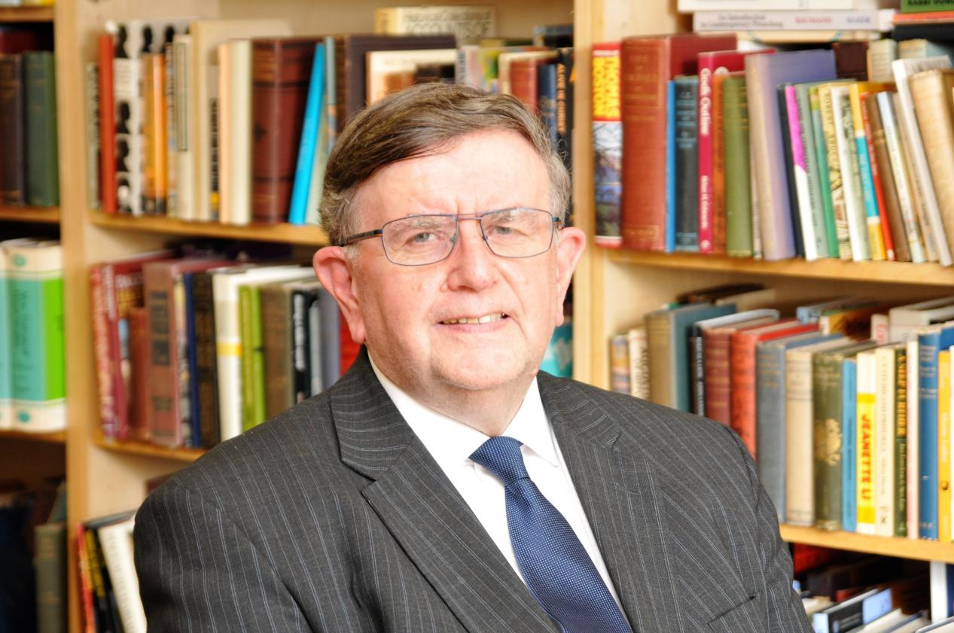

Rev Malcolm H Watts
The Rev Malcolm Watts served as Minister of Emmanuel Church, Salisbury from 1971 until his retirement from pastoral ministry in 2021, after 50 years of faithful service.
He was brought up in a Christian home in Barnstaple, North Devon and was called by grace in his teenage years, and subsequently called into the ministry. He trained at London Bible College between 1967-70.
He married Gillian in 1976, and together they have two daughters and a number of grandchildren.
Malcolm Watts is Chairman of the Salisbury Reformed Seminary and a Vice-President of the Trinitarian Bible Society. He is also a member of the UK board of Hudson Taylor Ministries and was instrumental in the production of Affirmation 2010.
He has authored a number of publications including The Lord Gave the Word: A study in the History of the Biblical Text (1998), The Worship of God (1998, co-author), The Government of the Church (2000, co-author), God's Hymnbook for the Christian Church (2003), The New King James Version: A Critique (2008), and What is a Reformed Church? (2011).
Malcolm Watts has also written a number of articles, many of which have been published in the church's magazine, The Messenger, of which he continues to serve as Editor.
https://www.salisburyemmanuel.org.uk/about-us/rev-malcolm-h-watts

Salisbury Reformed Seminary
CONFESSIONAL
To convince the students of the importance and value of Confessional Christianity, as seen in the London Baptist Confession of Faith (1689), the Westminster Confession (1647) and the Savoy Declaration of Faith and Order (1658), all three of these documents being essentially one, but differing in areas such as church government and the sacraments.
https://www.salisburyseminary.org/

Reformed, in the sense of recognizing the Holy Scriptures as God’s Word written, without error or fault in all its teaching, the only complete, sufficient and authoritative Rule for Faith and Practice, and therefore the means by which the Church should be reformed and restored to its apostolic and primitive form; also acknowledging Confessional Christianity, believing and teaching the truths set forth in the Second London Baptist Confession [1689], and showing the greatest respect for the two other 17th century Confessions upon which it was based and with which it was so much in agreement: the Westminster Confession [1647], the Savoy Declaration [1658]. Central to the Scripture’s revelation and the Confessions’ theology is the doctrine of sovereign, free and distinguishing grace, often and commonly identified as Evangelical Calvinism, which doctrine neither eliminates or excludes the presentation of Christ to sinners and the overtures of mercy to them, through the preaching of the Gospel.
https://www.salisburyseminary.org/our-mission-and-beliefs/

The Name – Christian February 13, 2004
https://banneroftruth.org/us/resources/articles/2004/the-name-christian/

Series
A selection of series of sermons preached by Rev Malcolm H. Watts are available online.
Westminster Shorter Catechism
https://www.salisburyemmanuel.org.uk/sermons/series

