公禱書
新加坡基督敎學術推進會出版, 1956.
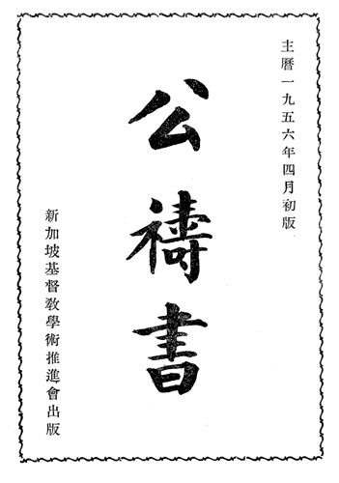
Download this book in Portable Document Format
新加坡會督序 |  | Preface by the Bishop of Singapore
聖會節期 |  | On the church's seasons
早晩禱文 | 1 | The Order for Morning and Evening Prayer
應時禱文 | 28 | Prayers
應時感謝文 | 42 | Thanksgivings
總禱文 | 44 | The Litany
聖餐禮前備禮文 | 55 | Order of Preparation for Holy Communion
聖餐禮文（甲） | 58 | First Order of Holy Communion
聖餐禮文（乙） | 84 | Second Order of Holy Communion
週年祝文書信福音 | 114 | Collects, Epistles and Gospels
聖洗禱文 | 313 | The Ministration of Baptism
教會問答 | 344 | The Catechism
堅振禮文 | 355 | The Order of Confirmation
婚姻禱文 | 361 | The Form of Solemnization of Matrimony
婚姻聖餐禱文 | 370 | Holy Communion at the Form of Solemnization of Matrimony
婦女分娩後感謝文 | 372 | Thanksgiving of Women after Childbirth
慰問病人文 | 376 | The Visitation of the Sick
終送禱文 | 388 | Ministration at the Time of Death
殯殮禮文 | 394 | The Order for a Funeral
安葬禱文 | 399 | The Order for Burial
在墓地用禱文 | 411 | Prayers to be Used at a Cemetery
孩童安葬禮文 | 424 | The Order for the Burial of a Child
接收學道友禮文 | 436
派立會督會長會吏禮文 | 441 | The Ordinal
派立會吏禮文 | 442 | Form and Manner of Making Deacons
派立會長禮文 | 449 | Form and Manner of Ordering Priests
祝聖會督禮文 | 463 | The Order for the Consecration of a Bishop
派立聖職總禱文 | 476 | The Litany for Ordinations
授任牧正禱文 | 480 | Order of Institution
祝堂成聖禱文 | 488 | The Order for the Consecration of a Church
新居入伙福文 | 497
訂婚儀節 | 501 | The Order for Betrothal
詩篇 | 503 | The Psalter
聖公會綱 | 648 | The Articles of Religion
毎日讀經表 | 668 | Tables of Readings
This translation of the Book of Common Prayer into Chinese was published by the Diocese of Singapore during the episcopate of Henry Wolfe Baines (1905-1972; diocesan bishop 1949-1960).
David Griffiths identifies this translation as 18:35 in The Bibliography of the Book of Common Prayer 1549-1999 (London: The British Library; New Castle, Delaware: Oak Knoll Press, 2002). An abridged edition of the prayer book was published in 1964. Chinese-speaking Anglicans in the Province of the Anglican Church in South East Asia, of which the Diocese of Singapore is a part, now use a revised service book published in 1999.
This book was digitized in 2011 by Richard Mammana from a copy of the original provided by Thomas Rae.

http://mammana.org/bcp/singapore1956/

