公禱書
在華北教區試用, 主教鄂方智
The Book of Common Prayer in Chinese, authorized for the Diocese of North China, 1937.
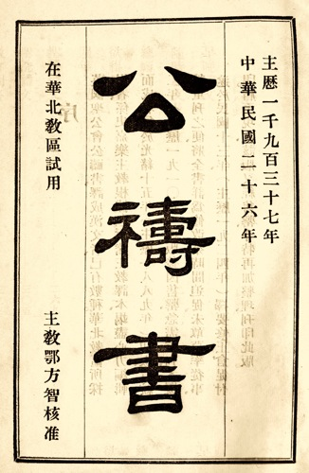
Download this book in Portable Document Format [17.2 MB]
序 |  | Preface
早晩禱文 | 1-27 | The Order for Morning and Evening Prayer
隨時禱文及謝文 | 29-45 | Occasional Prayers and Thanksgivings
總禱文 | 47-59 | The Litany
欲得救 | 61-65
週年之祝文書信之福音 | 67-268 | Collects, Epistles and Gospels
聖餐禮文 | 269-304 | The Order for Holy Communion
聖洗禱文 | 305-322 | Holy Baptism
教會問答 | 323-334 | The Catechism
堅振禮文 | 335-342 | The Order for Confirmation
婚姻禱文 | 343-351 | Holy Matrimony
婦女分娩後感謝文 | 352-354 | Thanksgiving of Women after Childbirth
慰問病人文及聖餐禮文 | 355-363 | Visitation of the Sick
殯葬禮文 | 367-385 | The Order for Burial
刻責文 | 386-389 | A Commination
詩篇 | 396-480 | The Psalter
接收禮文 | 484-491
家庭禱文 | 492-502 | Family Prayers
This translation of the Book of Common Prayer into Chinese was published for the Diocese of North China during the episcopate of Francis Lushington Norris (1864-1945; diocesan bishop 1914-1940). The title page uses the Minguo calendar of the Republic of China as well as the Christian year 1937.
David Griffiths identifies this translation as 18:33 in The Bibliography of the Book of Common Prayer 1549-1999 (London: The British Library; New Castle, Delaware: Oak Knoll Press, 2002).
This book was digitized in 2011 by Richard Mammana from a copy of the original provided by Thomas Rae.

http://mammana.org/bcp/chinese/north_china1937/

